NAME____________________________LAB MEETING DAY/TIME______________

Lab 5 Fossils - KEY

For the first part of Lab 5, you will be identifying a set of fossils. These are placed around the lab room, and you need to identify 10 fossils. You should use Exercise 8 pre-reading materials AND pages 174-188 of Exercise 12 when working on your identifications.

# **Fossil Samples**

You are provided samples of fossils around the lab classroom; choose 10 of these to identify Examine each sample carefully, make a rough sketch of the fossil, record its distinguishing characteristics, and then decide on a fossilization mode, name, and likely phylum of the fossil. NOTE: these fossils are all from Kingdom Animalia.

***Students should identify at least 10 of the 19 samples. Descriptions should include a sketch and a listing of defining characteristics.***

|  |  |  |  |  |
| --- | --- | --- | --- | --- |
| **Sample** | **Sketch and description** | **Name** | **Fossilization mode** | **Phylum** |
| 1 |  | Trilobite | Cast/Mold | Arthropoda |
| 2 |  | Brachiopod | Replaced or Cast/Mold | Brachiopoda |
| 3 |  | Sea Urchin or Echinoid | Replaced or Original hard parts | Echinodermata |
| 4 |  | Belemenite / Cephlapod | Recrystallized or Permineralized | Mollusca |
| 5 |  | Graptolite | Carbonization | Hemichordata |
| 6 |  | Crinoid / Sea Lily | Replaced or Cast/Mold | Echinodermata |
| 7 |  | Ammonoid / Cephalopod | Replaced, or permineralized | Mollusca |
| 8 |  | Sponge | Replaced or Cast/Mold | Porifera |
| 9 |  | Tabulate Coral | Replaced | Cnidaria |
| 10 |  | Bryozoan (stems) | Replaced | Bryozoa |
| 11 |  | Gastropod | Replaced | Mollusca |
| 12 |  | Solitary Rugose Coral | Replaced | Cnidaria |
| 13 |  | Bivalve | Original Hard Parts | Mollusca |
| 14 |  | Blastoid | Replaced | Echinodermata |
| 15 |  | Cephalopod w/ sutures | Permineralized | Mollusca |
| 16 |  | Colonial Rugose Coral (Petosky Stone) | Replaced | Cnidaria |
| 17 |  | Dendroid Graptolite | Carbonized | Hemichordata |
| 18 |  | Brachiopod | Replaced or Mold | Brachiopoda |
| 19 |  | Bryozoan | Replaced or Mold | Bryozoa |

Lab 5, Index fossils - KEY

For the second part of Lab 5, we will work through parts of Exercise 12, where you will be examining a suite of fossils (pictures) from a hypothetical field area. Your goal is to determine the geologic age of each rock group, based on the fossils present. We will skip the sections on depositional sequence, for now.

# **Exercise 12, Part A**

**Fauna 1 Fauna 2 Fauna 3**

*1a. Dickensonia 2a. Elrathia 3a. Cryptolithus*

*1b. Spriggina 2b. Asaphiscus 3b. Rafinesquina*

*1c. stromatolites 2c. Gogia (eocrinoid) 3c. Endoceras*

*2d. Peronopsis 3d. Platystrophia*

*2e. Acrothele 3e. Leptaena*

*2f. Archeocyatha 3f. Leperditia (ostracode)*

**Age = Proterozoic Age = Cambrian Age = Ordovician**

**Fauna 4 Fauna 5 Fauna 6**

*4a. Olenellus 5a. Tetragraptus 6a. Astraeospongia*

*4b. Peronopsis 5b. Phyllograptus 6b. Pentamerus*

*6c. Astylospongia*

*6d. Eurypterus*

*6e. Dalmanites*

*6f. Favosites*

**Age = Cambrian Age = Ordovician Age = Silurian**

**Fauna 7**  **Fauna 8 Fauna 9**

*7a. Atrypa 8a. blastoid (Pentremites) 9a. belemnite*

*7b. Paraspirifer 8b. Conularia 9b. Micraster*

*7c. Hydnoceras 8c. Girtyocoelia 9c. Monopleura (rudist)*

*7d. Phacops 8d. Neospirifer 9d. Pychnodonte*

*7e. Pachyphyllum 8e. Brachyspongia 9e. Scaphites*

*7f. Aulopora* *8f. Archimedes*  *9f. Exogyra*

*7g. Mucrospirifer 8g. Triticites or fusulinid 9g. Trigonia*

*7h. Syringopora*

**Age = Devonian** **Age = Pennsylvanian** **Age = Cretaceous**

# **Exercise 12, PART B**

***Students should write the ages on the figure below. Then, using the fauna from each, should make the following determination for the ages of the rocks.***

***Chuar Group = Proterozoic***

***Tremadoc = Cambrian to Ordovician***

***Labrador = Cambrian to Ordovician***

***Percha = Silurian***

***Salem = Devonian***

***Paradox = Pennsylvanian***

***Pierre = Cretaceous***

**7. Devonian**

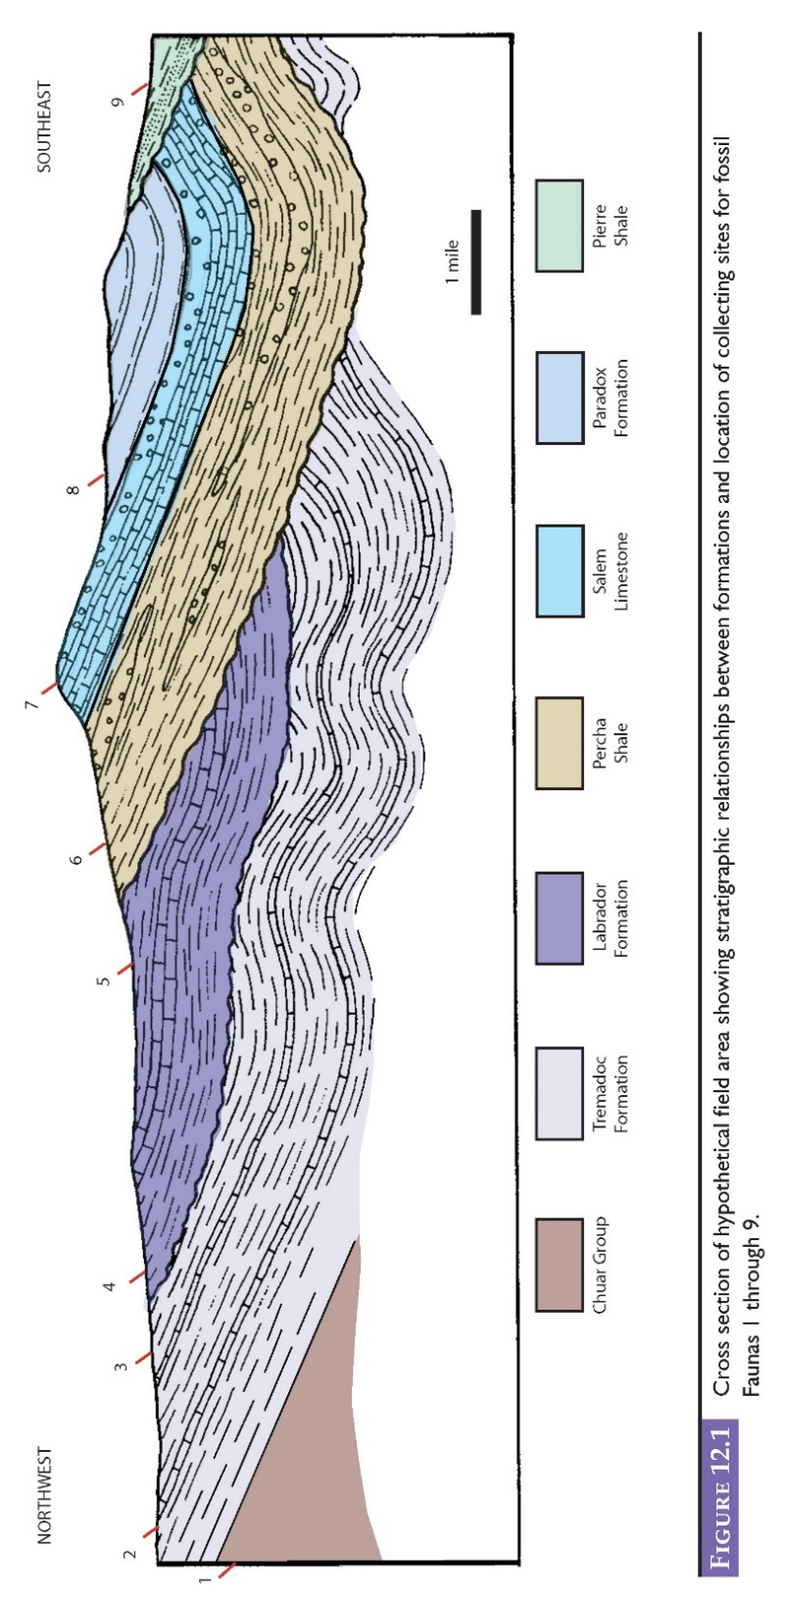

**9. Cretaceous**

**8. Pennsylvanian**

**6. Silurian**

**5. Ordovician**

**4. Cambrian**

**3. Ordovician**

**2. Cambrian**

**1. Proterozoic**

# **Lab 5 Reflection**

**Of the fossils we looked at today, what was the most interesting?**

**Explain how fossils can help with determining the age, sequence of events, and environmental history of an area…use a specific fossil as an example.**